Data Science Math Week 4 HW 1 & 3

For 2 & 4 See Rmarkdown document

1. Using matrix operations, describe the solutions for the following family of equations:

x + 2y - 3z = 5

2x + y - 3z = 13

-x + y = -8

This can be written as Ax = B in matrix form where

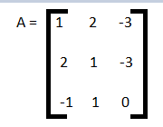

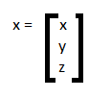

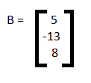

The determinant of A =

1 x ((1 x 0) - (-3 x 1)) - 2 x ((2 x 0) - (-3)(-1)) + (-3)((2 x 1) - 1(-1))

= 1 x (0 + 3) - 2 x (0 - 3) + (-3) x (2 + 1)

= 1 x 3 - (2)(-3) + (-3)(3)

= 3 + 6 - 9

= 0

If the determinant of a matrix is zero, then the system of equations is linearly dependent, and there is no unique solution.

3. Solve for AB by hand:

